
fdax tkWtZ fpfdRlk fo’ofo|ky;] m-iz-] y[kuÅA
lsUVªy gkLVy ,ykWVesaV lsy
osolkbZV % www.kgmcindia.edu Email : dean.studentwelfare@kgmcindia.edu
izks0 f{kfrt JhokLro fnukad 22-04-2025
phQ izkDVj

Proctorial Board
Various WebLink
S.L. | Description | Weblink
01 | Proctorial Board | https://www.kgmu.org/who_we_are.php
02 | Anti Ragging Squad and Committee | https://www.kgmu.org/anti_ragging_squad.php
03 | Provost List | https://www.kgmu.org/provost_various_hostels.php
04 | Anti Ragging Case | https://www.kgmu.org/anti_ragging.php
05 | Student Grievance | https://www.kgmu.org/student_grievance.php
06 | Sexual harassment of Women at Workplace | https://kgmu.org/sexual_harrasment.php

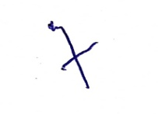
¼izks0 f{kfrt JhokLro½
phQ izkDVj
