Date:

AWARENESS PROGRAM ON WORLD DIABETES DAY(2021)-A BRIEF REPORT
An awareness program on the occasion of world Diabetes Day was conducted in Medicine OPD on 14th November, 2021 from 1PM Onwards. The program was attended by 10 consultants of the department, 40 residents and about 100-110 patients and their attendants in OPD.
This year’s theme of World diabetes day is “access to diabetes care”. So, the main aim of the program was to increase the awareness about the diabetes mellitus set of metabolic disorders so that they can benefit from the education of disease and treatment, dietary changes and lifestyle modifications. Prof. Virendra Atam, Head of the Department briefed about the contributions of the medicine department in the management of Diabetes patients. Prof. Kauser Usman explained the patients and their attendants about the risk factors and diagnosis of diabetes. Dr. Sudhir Verma, Associate Prof. gave brief insight about the complications of Diabetes. Other faculty members also presented their views on prevention and treatment of diabetes. Dr. Shalini, senior dietician briefed the audience about the dietary modifications in patients of diabetes.
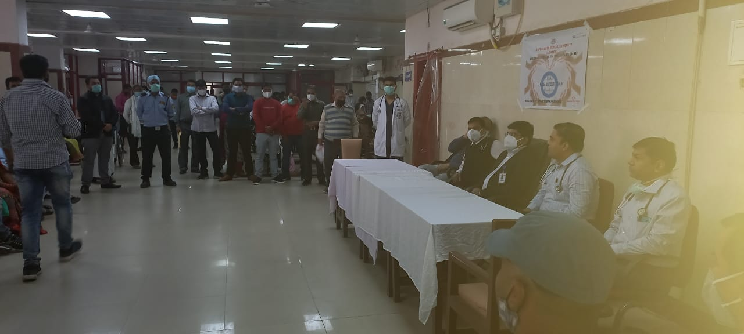
Though the program was conducted on small scale but it served the ultimate goal of awareness among the patients and their attendants.

Head
Department of Medicine

Date:

WORLD DIABETES DAY CELEBRATIONS(2021)-A REPORT

World Kidney Day was celebrated in the Neurology Basement Seminar Room on 11th March, 2021 from 1PM Onwards. The program was presided over by Prof. V Atam, Head of Department and was attended by 15 consultants of the department, 36 residents, 40 dialysis technicians trainees and other paramedical staff of the department.
The theme of World diabetes day 2021 is “Living well with Kidney Disease” with the objective to spread awareness about the increasing number of people contracting kidney diseases, with ultimate goal of encouraging life participation.Our department caters to the treatment large number of patients with kidney diseases ranging from acute to chronic kidney diseases. These activities further strengthen our knowledge base in the management of kidney diseases. . Prof. S.K Sonkar briefed about the contributions of the medicine department in the management of kidney patients. Prof. Kauser Usman explained the audience about the risk factors for kidney disease. Dr. Medhavi Guatam Associate Prof. conducted the quiz for dialysis technicians and post-graduates. It was then followed by demonstration of CRRT Machine for dialysis technicians and PG Residents.
Overall, the program was a grand success. 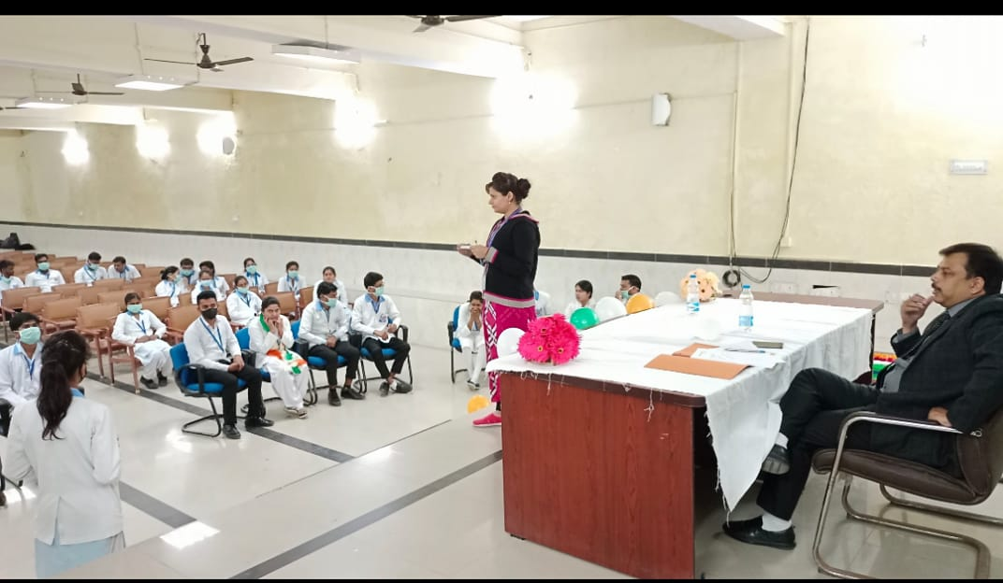

Head
Department of Medicine

Date:

AWARENESS PROGRAM ON WORLD DIABETES DAY(2021)-A BRIEF REPORT
An awareness program on the occasion of World AIDS Day was conducted in ART Centre, Medicine OPD on 1st December, 2021 from 12PM Onwards. The program was attended by Prof. K K Sawlani, Dr. D Himanshu(Nodal Officer, ART Centre) and other faculty members and residents from the department of Medicine. The program was attended by some social organizations also-Vihan, Hind Vikas seva sansthan, helping hand society.
Dr. D Himanshu, Nodal Officer ART Centre briefed the audience about the social and awareness campaign run by the centre in different parts of the city. He told the patients and relatives that only awreness about HIV can prevent us from this infection.He also emphasized the importance of ART in patients living with HIV-AIDS(PLHIV).
A signature campaign was also organized by the ART centre and it was followed by a skit by nursing students regarding awareness from HIV AIDS.

Head
Department of Medicine

