Report regarding Community Program by Department of Ophthalmology, KGMU at Sarojini Nagar

- Name of the activity- Weekly OPD for rural patients
- The department team visits CHC Sarojini Nagar, Lucknow every Monday and provides OPD, Refraction and counselling services to the rural patients.
- The team consists of a Senior Faculty, a Senior Resident, a junior resident, an optometrist and optometry students. The team caters to about 30-40 patients in each visit.
- The rural patients receive expert advice and treatment at their doorstep. The residents receive training and an opportunity to sharpen their skills under guidance. The patients who cannot be managed at during the visit are referred to Eye Department, KGMU for specialised care. They are also entitled to undergo surgery free of cost under the National programme for control of Blindness (NPCB).
This outreach programme is also an opportunity for students to learn about the various national programmes and see the working of health care delivery in semi urban and rural settings. Works like a win-win situation for everyone.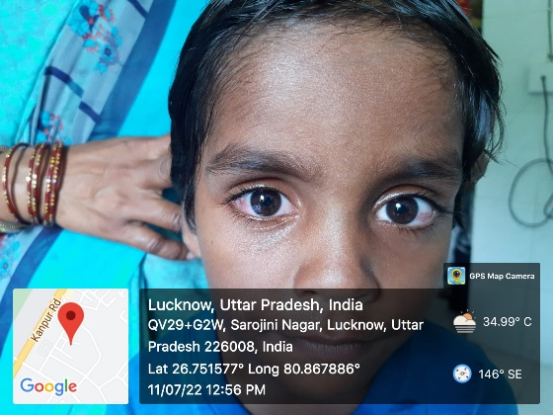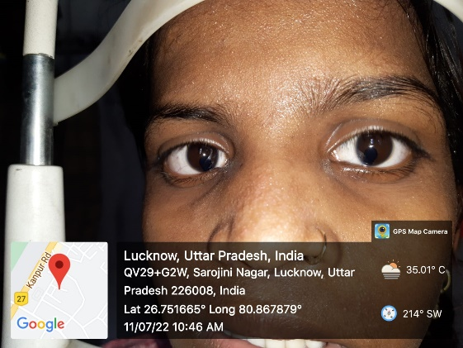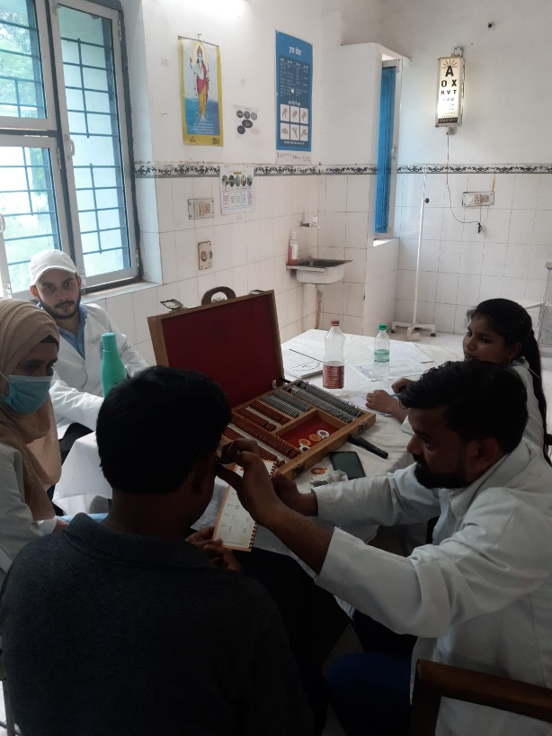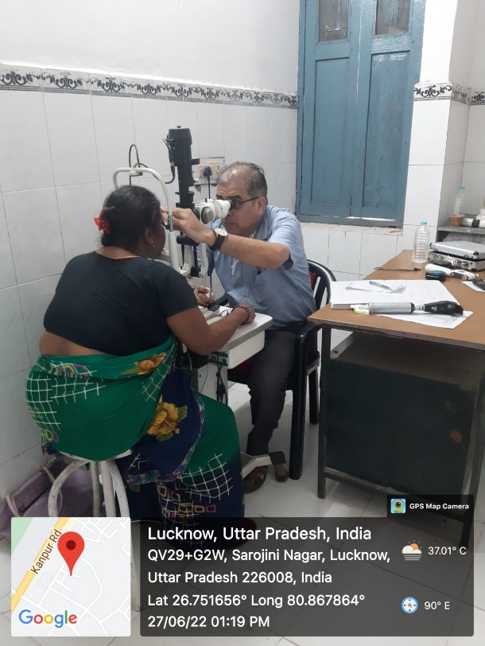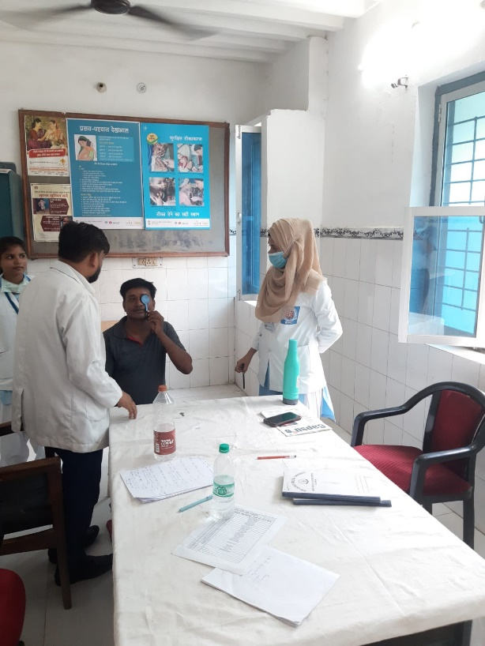

Report regarding Outreach Program by Department of Ophthalmology, KGMU at Rural Health Centre,Banthara

- Name of the activity- Weekly OPD for rural patients
- The department team visits Rural health Training Centre,Banthara Lucknow every Saturday and provides OPD, Refraction and counselling services to the rural patients.
- The team consists of a Senior Resident, a junior resident and an optometrist. The team caters to about 10-15 patients in each visit.
- The rural patients receive expert advice and treatment at their doorstep. The residents receive training and an opportunity to sharpen their skills under guidance. The patients who cannot be managed at during the visit are referred to Eye Department, KGMU for specialised care. They are also entitled to undergo surgery free of cost under the National programme for control of Blindness (NPCB).
This outreach programme is also an opportunity for students to learn about the various national programmes and see the working of health care delivery in semi urban and rural settings. Works like a win-win situation for everyone.

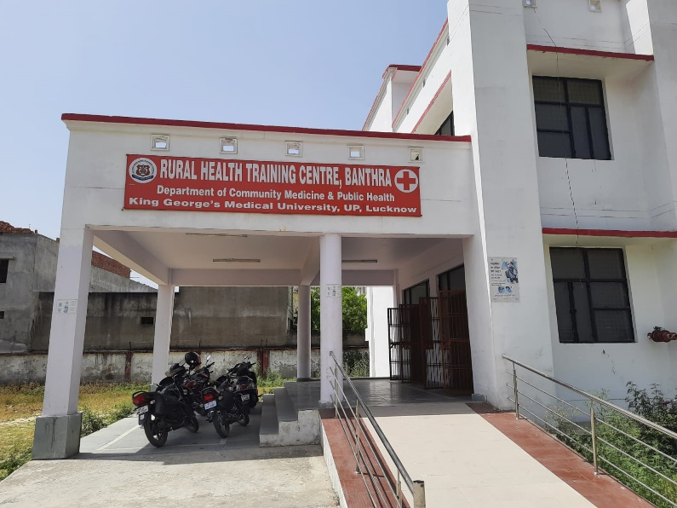

Report regarding Community Program on World Glaucoma Week by Department of Ophthalmology, KGMU at Sarojani Nagar

The department organised an awareness programme during the World Glaucoma Week between March 6 and 12, 2022 at CHC Sarojani Nagar. A faculty, 4 residents and several students of optometry participated in it. About 40-50 patients underwent screening for Glaucoma during this period. Treatment was advised to all and some were referred to Eye Department KGMU for investigations and Surgery.

