Social Outreach Programs
FOOD DISTRIBUTION FOR PATIENTS AND ATTENDANTS IN DECEMBER 2019
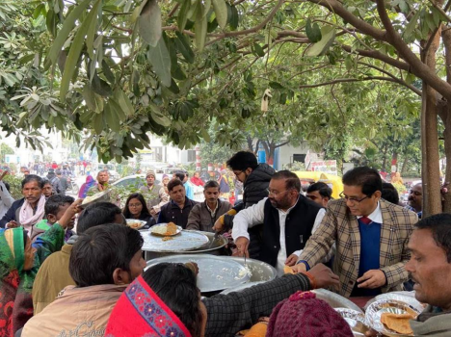
DENTAL CHECKUP CAMP ORGANISED BY KING GEORGE’S MEDICAL UNIVERSITY, LAKHIMPUR 2019
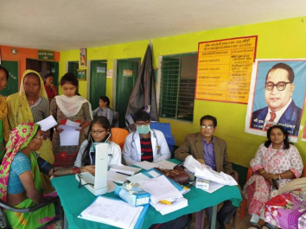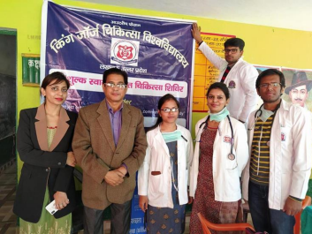
CYCLE YATRA TO SPREAD PUBLIC AWARENESS FOR HEALTH 2020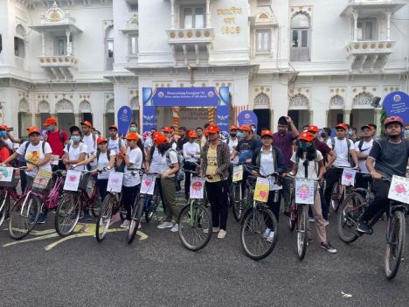

FOOD DISTRIBUTION CAMP DURING COVID TIMES MAY 2020 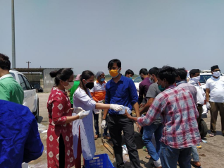 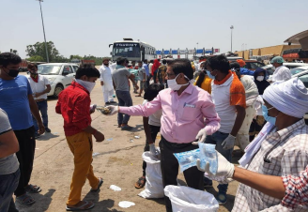

DENTAL HEALTH CHECK UP CAMP AT MAA PATAN DEVI 2020 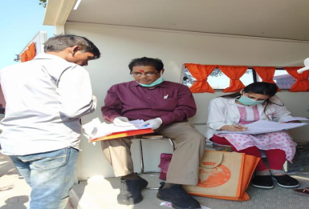
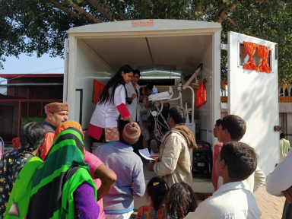
AYUSHMAN BHARAT PRADHANMANTRI JAN AAROGYA YOJNA PATAN DEVI 2020
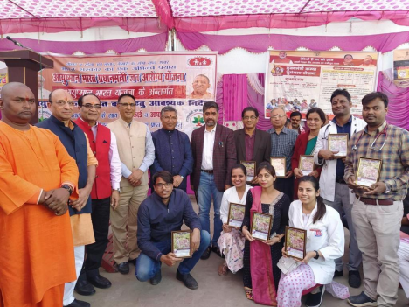

DENTAL HEALTH CHECKUP CAMP, KAKORI 2020

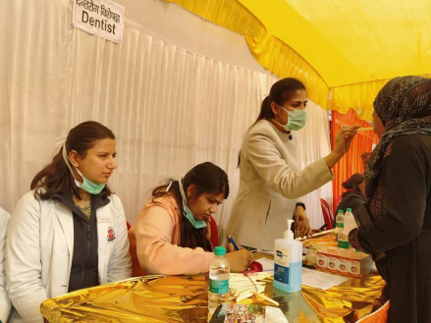
TREE PLANTATION DRIVE BY DEPARTMENT OF PROSTHODONTICS ON PROSTHODONTIST DAY’2021
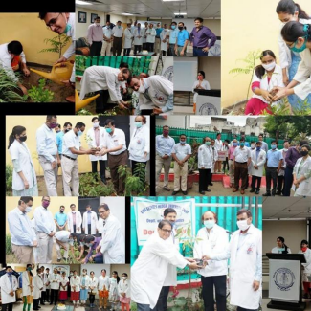
GURU GORAKSHNATH SWASTH SEWA YATRA- SHRAVASTI 2021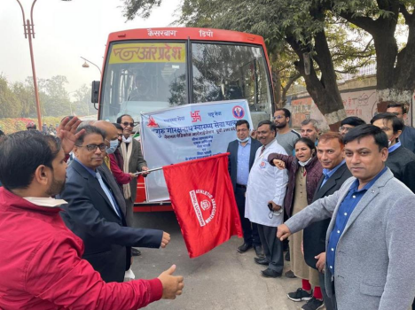
GURU GORAKSHNATH SWASTH SEWA YATRA ORGANISED BY NATIONAL MEDICOS ORGANISATION- AYODHYA, NOVEMEBER 2021

